Medicaid Exit and Dependency
Introduction
Medicaid is the federal and state funded project that provides health care to low-income citizens. To receive Medicaid a potential enrollee must apply during an open enrollment period and will be awarded coverage based on their household size and monthly income. There is criticism on the quality of healthcare coverage, and it often leads participants to exit the program in search of a better cost-effective health care coverage (Ndumele, Schpero, Schlesinger, & Trivedi, 2017). Union County, New Jersey provided their enrollment data for the county residents that are enrolled in the New Jersey state Medicaid program. Figure 1 illustrates the clusters of Medicaid participants. Machine learning is a part of artificial intelligence where a computer can be coded to create training data that can potentially make predictions. Machine learning was used to examine the attributes of participants that reside in Union County. If participants have a large number of children, then they are more likely to stay in the Medicaid program, and if the participants have no personal vehicle then these participants are more likely to rely on the program.
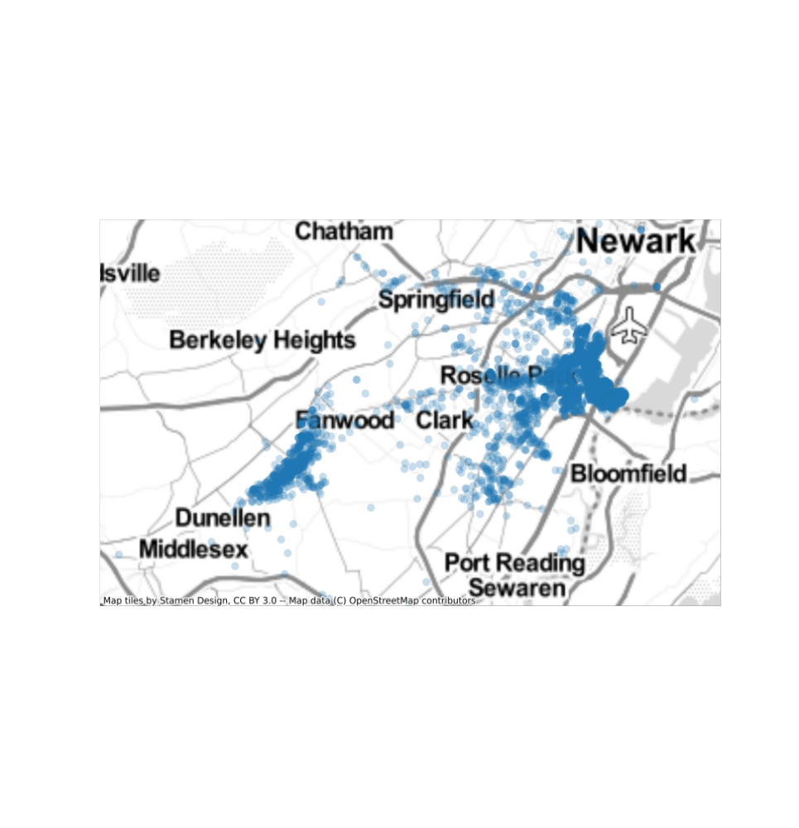Figure 1: Medicaid Participant Cluster Union County
Background
Data preparation is a tedious but important part of using Machine Learning and feature cleaning is a part of this data preparation and the most important part of using machine learning. (Gupta & Sedamkar, 2020). In feature cleaning there will be missing values, and using the best discretion these missing values can be deleted or treated with codes to make up for the imperfect data (Gupta & Sedamkar, 2020). When treated the data needs to be deleted and if data is deleted then the testing can be limited based on feature class availability. Deletion has more information loss and to avoid that a data scientist may prefer to use imputation, which provides a wide variety of machine learning methods to impute data (Gupta & Sedamkar, 2020). Once the features are cleaned then they can be engineered for transformation for proper machine learning formats. After the features are transformed, they become extracted, selected, and may be used to make precise model predictions (Gupta & Sedamkar, 2020).
Data Preprocessing
The testing data was split into training and testing data, the target column was removed from the original data set. The new x_value was designated to the testing data set. There were missing values in the training data set because it was not perfect. The X_train data set was examined and it was decided that the column would need to be evaluated before the data set could be dropped or imputed. The number of missing columns from the X_train data were found by dividing the total number of observations from the data set. Three columns were discovered to have missing records, and because the missing data was biased there was a cause to remove the data. Similar missing values from the y_train data were removed as well. The column GENDER is a categorical feature and it needed to be converted into a numerical feature. The get_dummies function was used to make the column GENDER binary, with a number to indicate whether it was male. To eliminate redundancy, it was only coded to show if the participant was male, and if it was not male then for obvious reasons it is assumed to be female. The data then counted the number of former participants of the program and it was found to be unbalanced. More participants remained in the program than participants that left the program. The data was balanced by up sampling the minority group up to the total number in the majority group. The data was then ready for the next step to have the features cleaned.
The features were cleaned with gradient boosting which added predictors to correct its predecessors and to minimize the loss of data (Gupta & Sedamkar, 2020). The best evaluation method to be used was either the recall or precision separately or together. It was used because the data would not show to be biased and the F1 score was used to include the recall and precision of the model. The GradientBoostingClassifier was imported because the targets are categorical. The learning_rate was missing so it was added to the data as a decimal result. The GradientBoostingClassifier model was given parameters for cross evaluation and the F1 score was maximized; the larger the F1 score the better the model performance. The best combinations of the hyperparameter were discovered to be n_estimators , max_depth max_features, min_samples_split, and learning_rate.
Machine Learning Results: The same preprocesing method was applied to the X_test data and y_test data sets and the null values were dropped. The Machine Learning model was then developed with the best set of hyperparameters. The GradientBoostingClassifier were initialized using the hyper parameters n_estimators, max_depth max_features, min_samples_split, and learning_rate. Then the test data was fitted to the X_train _upsampled data and the y_train_upsampled data sets. The y_predict value was retrieved by using the X_test data. The data was then evaluated to see the performance of the model.
Machine Learning Results
 | labels | precision | recall | fscore | support
0 | 0 | 0.790761 | 0.799451 | 0.795082 | 364
1 | 1 | 0.676991 | 0.665217 | 0.671053 | 230
Table 1: Confusion Table
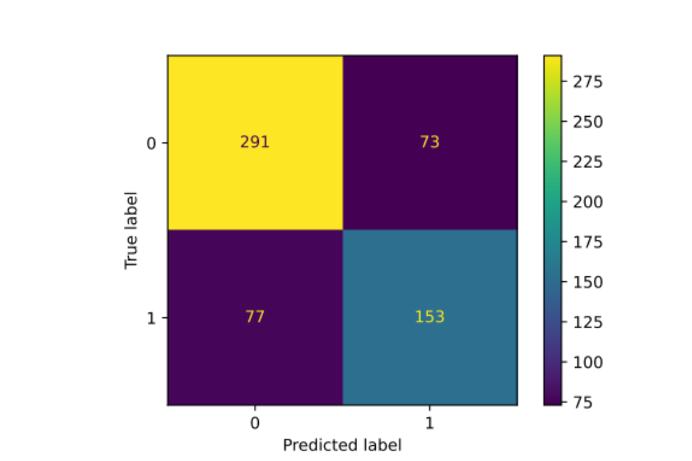
Figure 2 Confusion Matrix
Table 1 writes that the precision, recall, and fscore for 0 is very good, and for 1 it is not good. The confusion matrix shows that the purple sections with 73, and 77 respectively still have cases of misclassification. The y_predict_proba was calculated for an roc_auc_score and found to be 0.8086777353081701 which indicates that the data was not randomly assigning the sample to be 0 or 1, anything about 0.5 is good.
Interpretable Machine Learning Results
 | features | score
19 | duration | 0.445758
20 | age_lastyear | 0.127749
25 | nonwork_income | 0.092006
26 | total_income | 0.091745
24 | work_income | 0.067919
22 | num_kids_lastyear | 0.038390
Table 2: Top 6 Important Features from Model
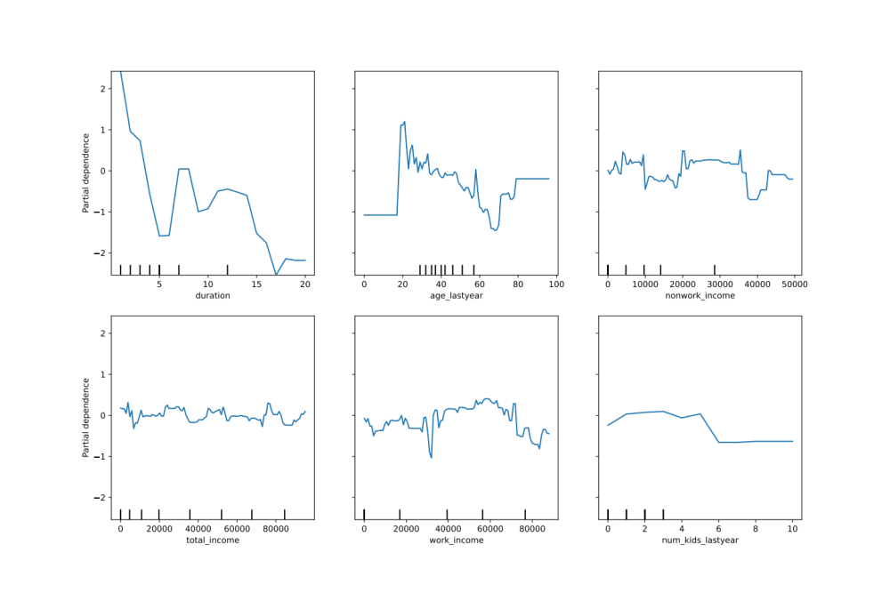
Figure 3: PDP Plots for Top 6 Important Features
The features were generated to show the actual name of the columns to produce the tables. The results in Table 2 are from the most important to the lesser important categories. Both X_test and X_train data was used to plot the tables in Figure 3. It is harder for a participant to leave the program with increased time spent in the program. The longer a participant is in the program. The higher age or older a participant is, it is harder for that person to leave the program. Non-work income, total income, and work income were inconclusive to the participation in the program. The more children in a household the more dependent a participant is on the program.
Conclusion
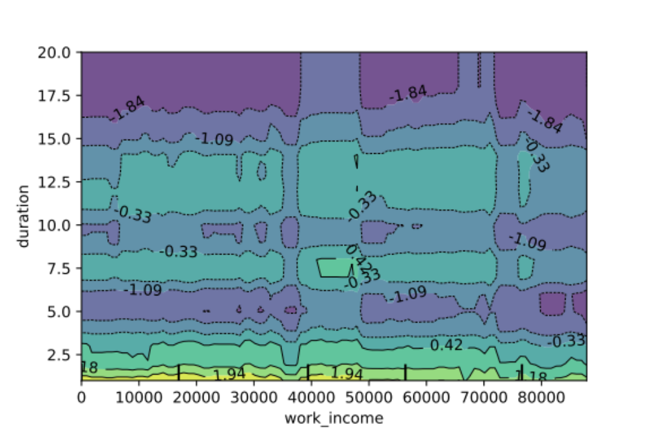
Figure 4: Number of Children versus Program Duration

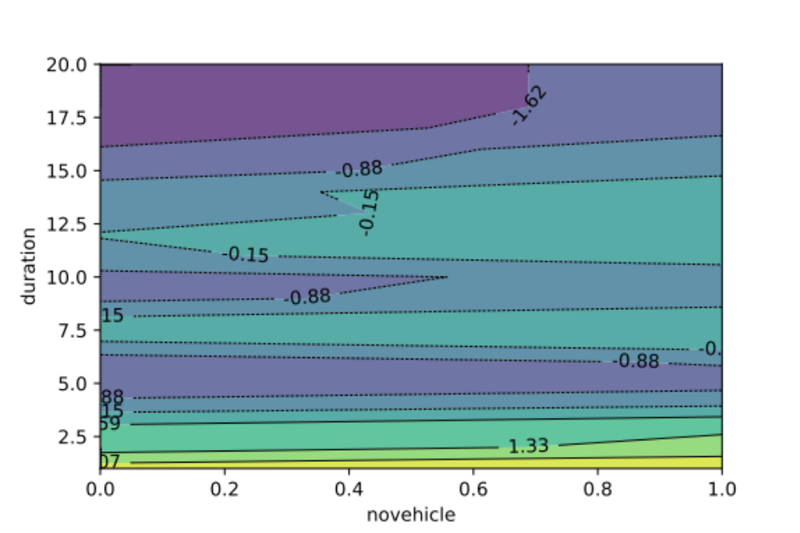
Figure 5: Car Ownership versus Program Duration

There is not much interaction in Figure 4, so work income is not a dominant factor in determining the duration in the Medicaid program. Whether the participant has a lot of children does not affect how long they are in the program. There is not much interaction in Figure 5, so the ownership of a personal vehicle is not a dominant factor in determining the duration in the Medicaid program. Whether the participant has a personal vehicle does not affect how long they are in the program.

Works Cited
Gupta, S., & Sedamkar, R. R. (2020). Machine Learning for Healthcare: Introduction. Machine Learning with Health Care Perspective, 1-25.
Hyer, J. M., Paredes, A. Z., White, S., Ejaz, A., & Pawlik, T. M. (2020). Assessment of utilization efficiency using machine learning techniques: A study of heterogeneity in preoperative healthcare utilization among super-utilizers. The American Journal of Surgery, 714-720.
Ndumele, C. D., Schpero, W. L., Schlesinger, M. J., & Trivedi, A. N. (2017, June 20). Association Between Health Plan Exit From Medicaid Managed Care and Quality of Care, 2006-2014. Journal of American Medical Association, 2524-2531.

